September Saturdays- 7, 14, 21, 28
Theme: Stamp-a-Palooza!
Bubble Wrap, Corks, and Legos
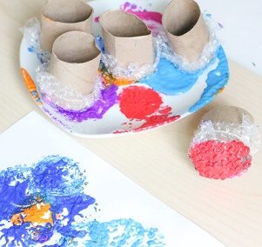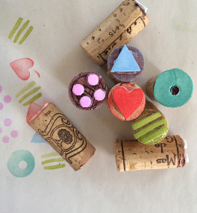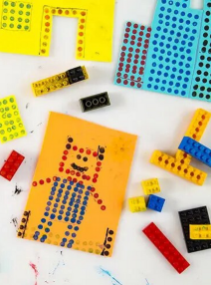
October Saturdays- 5, 12, 19, 26
Theme: Cats, Bats, and Pumpkins, Oh My!
Paper Construction, Color Mixing, and Air Dry Clay
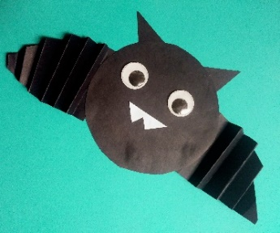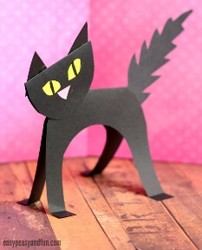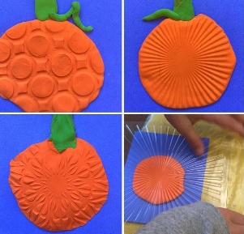
November Saturdays- 2, 9, 16, 23
Theme: Leaves, Hedgehogs, and Turkeys Please!
Watercolor Painting, Pom-Pom Making, and Turkey Doodling
